
FACULTY OF ENGINEERING
DIPLOMA ENGINEERING
DEPARTMENT OF COMPUTER ENGINEERING
SOFTWARE ENGINEERING (DE103304)

Unit 2 Software Requirement Analysis and Design

1. Requirement Gathering & Analysis
Requirements from the end user play a key role in developing a software product. The task of gathering and analyzing requirements is performed by the System Analyst.
The analyst collects information from the customer and analyzes it to remove ambiguity and inconsistencies.
There are two main activities:
- Requirement Gathering
- Requirement Analysis

2. Requirement Gathering
Requirement gathering is the first activity in the Software Development Life Cycle (SDLC).

Goal
To collect all relevant information from the customer regarding the software to be developed.

Main Focus
- Meeting with customers
- Analyzing market demand
- Understanding product features

Requirement Gathering Activities
- Studying existing documents
- Interviewing end users
- Task analysis
- Scenario analysis
- Brainstorming
- Questionnaires

3. Requirement Analysis

Goal
To understand the exact requirements of the customer.
Requirement analysis helps to:
- Understand requirements
- Interpret requirements
- Classify requirements
- Organize requirements
- Check feasibility
- Ensure completeness
- Ensure consistency

Activities Involved

1. Eliciting Requirements
Requirements are gathered by communicating with customers to identify their exact needs.

2. Analyzing Requirements
Requirements are analyzed to make them:
- Complete
- Clear
- Unambiguous

3. Requirement Recording
Requirements are documented in forms such as:
- Use Cases
- Process Specifications
- Other Requirement Documents

Output
The output of Requirement Gathering and Analysis is the Software Requirement Specification (SRS) document.

System Requirement Specification (SRS)
- SRS: A document that describes what the software should do, not how it will do it.

Characteristics of a Good SRS
- Correct: Right requirements.
- Unambiguous: Clear meaning.
- Complete: All requirements included.
- Ranked: Requirements prioritized.
- Modifiable: Easy to update.
- Traceable: Easy to track.
- Verifiable: Can be tested.
- Consistent: No conflicting requirements.

Functional and Non-Functional Requirements

Functional Requirements

- Describe what the system should do.
- Define the features and functions of the software.
Examples (Hotel Management System):
- Book a room.
- Check-in and check-out customers.
- Cancel or modify reservations.
- Record customer details.
- Generate bills.
- Record food orders and payments.

Non-Functional Requirements
- Describe how the system should work.
- Focus on quality, performance, security, and reliability.

Types
- Product Requirements: Speed, reliability, performance.
- Organizational Requirements: Company standards and development rules.
- External Requirements: Legal rules and compatibility with other systems.
Examples (Hotel Management System):
- Login within 5 seconds.
- Screen loads within 2 seconds.
- System runs on Windows.
- Developed using Java.
- Secure login with username and password.
- System available during hotel working hours.

Classification of Design Methodology
Software design methodologies are mainly classified into two types:

1. Function-Oriented Design (Structured Design)
- Focuses on functions or processes of the system.
- Divides the system into small functions/modules.
- Uses Data Flow Diagrams (DFD) and Structure Charts.
- Suitable for small and medium-sized projects.
Example: Library Management System where functions like Issue Book, Return Book, and Search Book are designed separately.

Advantages
- Simple to understand.
- Easy to develop small applications.
- Good modularity.

Disadvantages
- Difficult to maintain large systems.
- Data and functions are separate.

2. Object-Oriented Design (OOD)
- Focuses on objects and classes.
- Combines data and functions into a single unit called an object.
- Uses UML diagrams such as Class Diagram, Use Case Diagram, and Sequence Diagram.
- Suitable for large and complex software projects.
Example: Student Management System with objects like Student, Teacher, and Course.

Advantages
- Easy to maintain and reuse code.
- Provides better security through encapsulation.
- Suitable for large projects.

Disadvantages
- More complex than function-oriented design.
- Requires knowledge of object-oriented concepts.

Cohesion and Coupling

Cohesion

Definition
Cohesion means how closely related the tasks inside a module are.
A module with high cohesion performs one specific task only, which makes it easier to understand and maintain.

Example
A Calculator module only performs:
- Addition
- Subtraction
- Multiplication
- Division
All tasks are related, so it has high cohesion.

Advantages
- Easy to understand
- Easy to maintain
- Easy to test
- Fewer errors
Remember: High Cohesion is Good.

Coupling

Definition
Coupling means the level of dependency between two modules.
If one module depends too much on another, it has high coupling.

Example
Module A sends data to Module B only when needed.
- If they work mostly independently → Low Coupling (Good)
- If one cannot work without the other → High Coupling (Bad)

Advantages of Low Coupling
- Easy to modify
- Easy to reuse
- Easy to test
- One module can change without affecting others
Remember: Low Coupling is Good.

Data Modeling Concepts
Data Modeling is the process of organizing and representing data in a database.
It helps developers understand what data is needed and how different data items are connected.
Main concepts are:
- Data Objects
- Data Attributes
- Relationships
- Cardinality
- Modality

Data Object

Definition
A Data Object is a real-world person, place, thing, or event about which information is stored.

Examples
- Student
- Employee
- Customer
- Book
- Product
Example:
Student is a data object.

Data Attribute

Definition
A Data Attribute is a property or characteristic of a data object.

Example
Data Object: Student
Attributes:
- Student ID
- Name
- Age
- Address
- Mobile Number
Another Example
Data Object: Employee
Attributes:
- Employee ID
- Name
- Salary
- Department

Relationship

Definition
A Relationship shows how two or more data objects are connected.

Example
- Student enrolls in Course
- Customer places Order
- Teacher teaches Subject

Cardinality

Definition
Cardinality tells how many instances of one data object are related to another.

Types of Cardinality

One-to-One (1:1)
One person has one passport.
Example:
- Person → Passport

One-to-Many (1:M)
One teacher teaches many students.
Example:
- Teacher → Students

Many-to-One (M:1)
Many students belong to one class.
Example:
- Students → Class

Many-to-Many (M:N)
Many students study many subjects.
Example:
- Students ↔ Subjects

Modality

Definition
Modality tells whether participation in a relationship is mandatory or optional.

Types

Mandatory (1)
The object must participate in the relationship.
Example:
Every employee must belong to one department.

Optional (0)
The object may or may not participate in the relationship.
Example:
A customer may place an order, but it is not compulsory.

Use case Diagram Symbols and Examples
(I)ATM Machine(II)Library Management System

Use Case Notations

Name | Notation |  |  | Description
System boundary |  | System |  | The scope of a system can be represented by a system boundary. The use cases of the system are placed in side the system boundary, while the actors who interact with the system are put outside the system. The use cases in the system make up the total  Requirements of the system.
Use case | UseCase1 |  |  | A use case represents a user goal that can be achieved by accessing the system or software application.
Actor | Actor |  |  | Actors are the entities that interact with a system. Although in most cases, actors are used to represent the users of system, actors can actually be anything that needs to exchange information with the system. So an actor may be people, computer hardware, other systems, etc. Note that actor represent a role that a user can play,  But not a specific user.
Association |  |  |  | Actorandusecasecanbeassociatedtoindicatethattheactorparticipates in that use case. Therefore, an association corresponds to a sequence of actions between the actor and use  Case in achieving the use case.
Generalizatio n |  |  |  | A generalization relationship is used to represent inheritance relationship between model elements of same type.
Include | <<include>> |  |  | An include relationship specifies how the behavior for the inclusion use case is inserted in to the behavior defined for the base use case.
Extends | <<Extends>> |  |  | An extend relationship specifies show the behavior of the extension  use case can be inserted into the behavior defined for the base use case.
Constraint | {condition} |  |  | Show condition exists between actors an activity.
Interface | Interface |  |  | Interface is used to connect package and use-case. Head is linked  With package and tail linked with use-case.
Anchor |  |  |  | Anchor is used to connect a note the use case in use case diagram

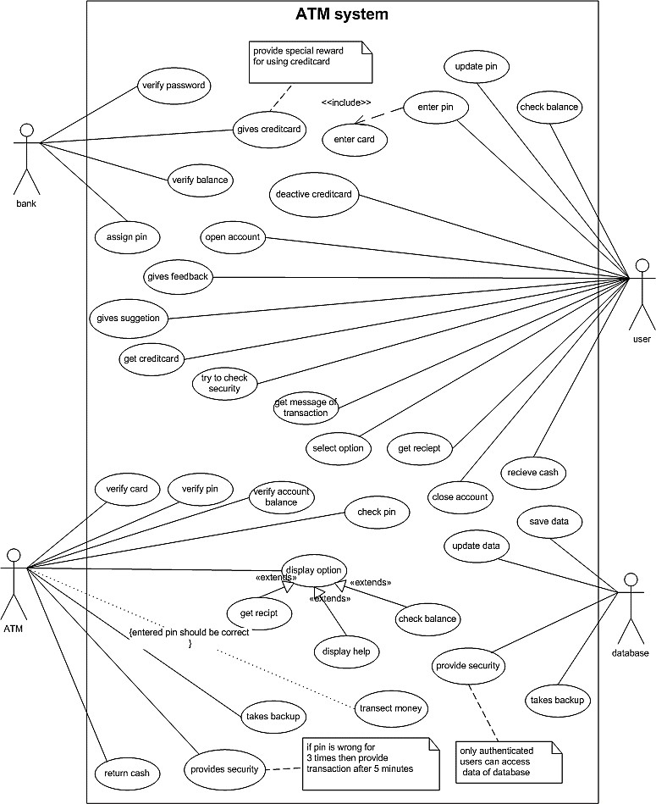

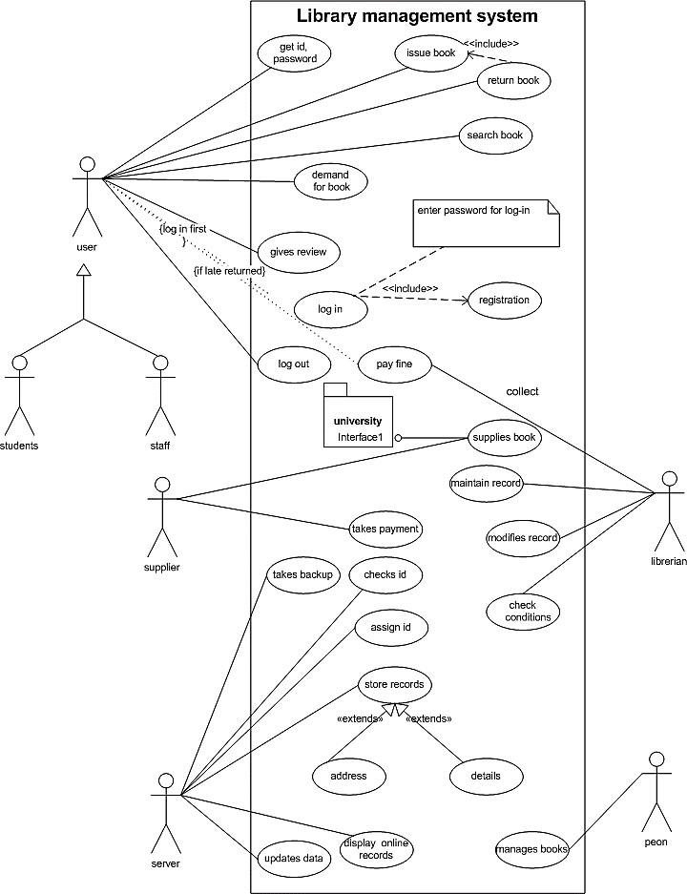

  - everyone is working from the same set of requirements

Context diagram and data flow diagram(DFD) for Airlines Reservation System.

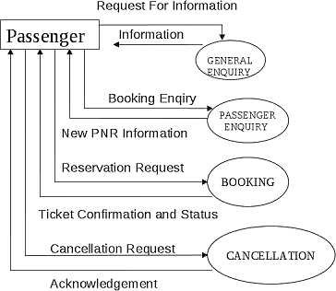
Context diagram /Level0DFD

Level1DFD
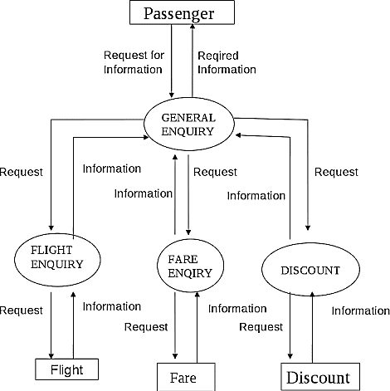

Level2DFD
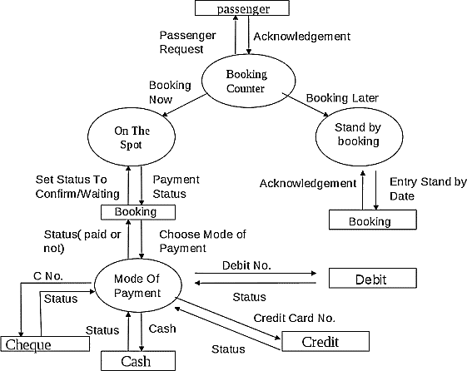

Activity Diagram
Creating an activity diagram based on the use case description of a use case is often easier than creating one from scratch because the use case description provides a clear and structured understanding of the steps involved in the use case. Specifically, the use case description outlines the preconditions, postconditions, alternative flows, exceptions, special requirements, and assumptions of the use case, which can be used to create a detailed and accurate activity diagram.
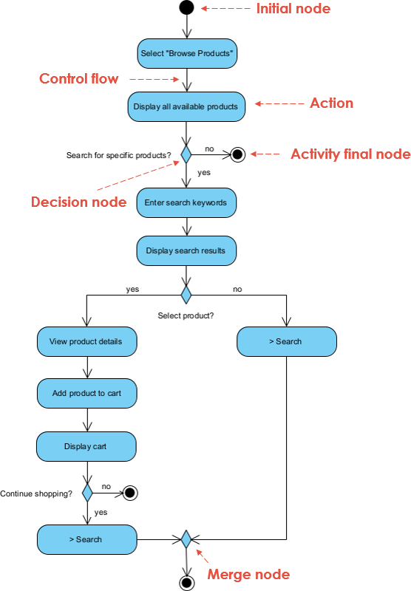
Here are some reasons why creating an activity diagram based on the use case description of a use case is easier:

  - Clear understanding of the use case: The use case description provides a clear understanding of the steps involved in the use case, making it easier to create an accurate activity diagram.
  - Consistency: By using the use case description as a basis for the activity diagram, you can ensure that the diagram is consistent with the requirements outlined in the use case description.
  - Time-saving: Creating an activity diagram from scratch can be time-consuming, but by using the use case description as a starting point, you can save time and effort.
Collaboration: Using a use case description as a basis for the activity diagram can facilitate collaboration among team members, as

